Membership
Membership in the Coffee County Historical Society is open to anyone interested in the history, genealogy, folklore and archaeology of Coffee County, Tennessee. (Other historical or genealogical societies that exchange regular publications with CCHS are exempt from dues payment.)
NEW MEMBERS WELCOME! Clip here and mail with ca check payable to CCHS.)
Name: __________________________________
Address:________________________________
________________________________________
Phone:__________________________________
Email: __________________________________
Check one:

____ $10 Coffee County Middle or
High School Student

------- $15 Electronic Member
(publications in PDF format)

____ $25 Individual Active Member

____ $25 Institutional, Contributing, or
Sustaining Member

____ $250 Life Member
Our bimonthly newsletter will be sent by email to members with an email address. Others will receive it by postal mail.

Welcome New Members!

Who We Are
  - (931) 728-0145
  - cchs1969@att.net www.cctnhs.org
Meetings are held at 1:00 p.m.
on the 2nd Saturday
of January, March, May, September and November
at the CCHS office in the Historic Courthouse on the square
in downtown Manchester.
Annual picnic in July,
time and place to be announced.

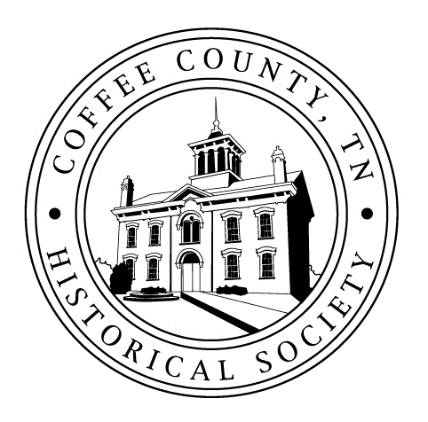

Visitors always welcome
COFFEE COUNTY HISTORICAL SOCIETY
101 W. Fort St., Box 2
Manchester, TN 37355

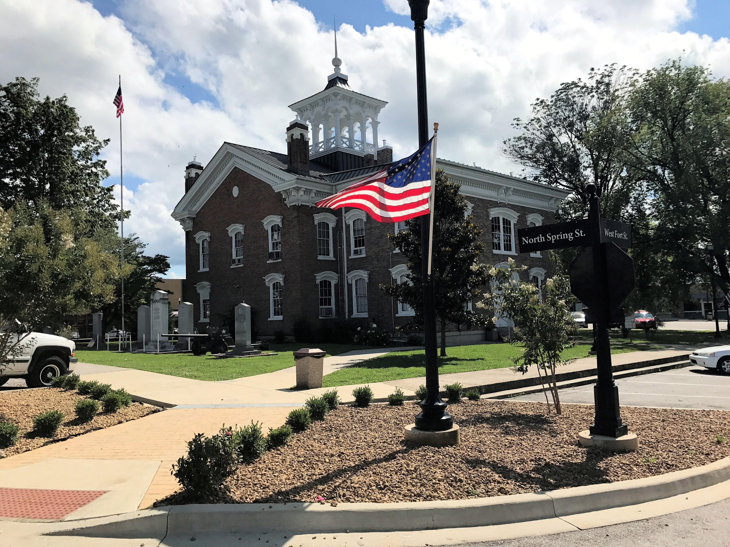

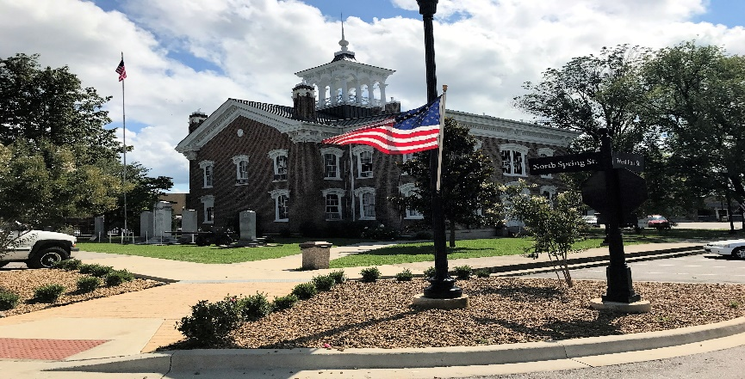
The Historical Society was established in 1969 for the purpose of bringing together people interested in history and genealogy, especially in Coffee County, as a way of promoting a better appreciation of our American heritage as well as collecting and preserving its documentation. Our office is located in the historic courthouse on the square in Manchester, Tennessee. A volunteer is available from 9:00 a.m. to 1:00 p.m. Tuesdays through Fridays for assistance in locating census, marriage, genealogy and other records, books, making reference materials available and selling publications.

Our Mission
The Society’s major function is to discover, collect and preserve material which may help establish or illustrate the history of the area its exploration, settlement, development and activities in peace and in war, its progress in population, wealth, education, arts, science, agriculture, manufacture, trade and transportation. The Society makes these materials accessible to anyone interested and disseminates historical and genealogical information by means of publications, lectures, discussions, media notification and programs to awaken public interest.

Gifts and Donations
Coffee County Historical Society is a 501(c)(3) organization. Donations from members and the community at large are tax-exempt and help the Society to preserve Coffee County’s history and strengthen and expand our programs. Your gift will support our mission to inspire and inform the public about the county’s role in the development of this state and country. Gifts of any amount are welcome, and you might consider including the Historical Society in your will.

_{(April 2022)}
Publications for Sale  1812 Bedford Co. Tax List (Vol. 16, 1-2).. …….$15.00  1836 Tax List (Vol. VI, 1)……………………………… $ 10.00  1840 Coffee Co. Census with 1841 Coffee State  Census (Spec. Pub. 5)…………………………………..$17.00  1850 Coffee Co. Census with Agricultural  and Slave Schedule (Vol. 18, 3-4)…………….$25.00  1860 Coffee Co. Census with Agricultural and Slave  Schedule (Spec. Pub. 4)………………………………$25.00  1870 Coffee Co. Census (Vol. 14, 2-4)…………$25.00  1880 Coffee Co. Census book………………..…..$30.00  1880 Coffee Co. Census CD……………………… $15.00  1880 Mortality Sched. (Vol. 9, 1-2)………..…..$15.00  Acts of the Gen. Assembly (Vol.8, 1-2)…..…..$15.00  Allison-Erwin Land Deal (Vol. 8, 3)………..……$ 10.00  Bailey Ice Book, Funeral Information  (Vol. 26, 4)……………………………………………….…$ 10.00  Banks Family of Noah, Cumberland Presbyterian  Church, (Vol. 25, 1)…………………………………….$ 15.00  Beans Creek Church, Coffee Co. Caves, Old Stone  Fort Map (Vol. 4, 1-3)…………………………….....$20.00  Beech Grove (Vol. 30, 4)…………………………….$17.00  Betsy Willis Misc.(Vol. 11, 2)………………………$15.00  Blue Springs Bapt. Church (Vol. 10, 2)………..$ 10.00  Civil War Era (Vol. 20, !-2)…………………………$15.00  Civil War Questionnaire (Vol. 15, 3-4)………..$15.00  Civil War Soldiers of Coffee Co. B 1(A-B)……$30.00  Civil War Soldiers of Coffee Co. Bk 2(C-F…..)$30.00  Civil War Soldiers of Coffee Co. Bk 3(G-J)…..$30.00  Civil War Soldiers of Coffee Co. Bk 4(K-Mc)..$30.00  Civil War Soldiers of Coffee Co. Bk 5(N-S) … $30.00  Civil War Soldiers of Coffee Co. Bk 6(T-Z) …. $30.00  Civil War Series (all 6 books at once)…….….$130.00  Civil War Books on searchable CDs…………..$15.00 ea.  Coffee Chronicle Vol. 4, No. 1 (Misc.)……....$20.00  Coffee Co. Cemetery locations & 1866 Tax List  (Vol. 24, 1-4)……………………………………………..$ 12.00  Coffee Co. & Manchester from Aboriginal Times  (Vol. 1, 1)………………………………………….……..$15.00  Coffee Co. Confetti (Vol.7, 2)……………………$15.00  Coffee Co. Fair History, CF Chronicle  (Vol. 2, 2) ……………………………………………….$20.00  Coffee Co. Loose Records (Vol. 22, 1-4)..….$30.00  Coffee Co. Memories (Chronicle 4, No. 2). $20.00  Coffee Co. Tax 1872-1874 (Vol. XIV, 1)……$ 10.00 |  |  | Cunnyngham Ledger (Vol. 19, 3-4)……………$15.00  Deaths in Coffee Co.1880-1900 (Vol. 9, 3)..$20.00  Early Businesses, Home Guard, Revolutionary  War (Vol.7, 1-4)……………………………………..$20.00  Early Coffee Co. (Vol. 17, 1&2)………………….$15.00  Ewell’s History Index (Spec. Pub. 2)…………..$ 7.00  Ferrells of Middle Tennessee…………………. .$30.00  Founding Families of Coffee County………… $20.00  Fountain Grove Church Minutes  (Vol. 13, 3-4)………………………………………….$15.00  Garrison Fork Church Minutes – Misc.  (Vol. 13, 1 and 2)………………………………..…$15.00  Genealogy from Beginning to DNA  (CF Chronicle Vol. 6, No. 2)…………………….$20.00  Guardianship Book (Vol. 21, 3-4)……………….$15.00  Hillsboro (Vol. 8, 4)……………………………………$20.00  Hurricane Springs Hotel (Spec. Pub. 3)………$ 10.00  Inventories – Other deaths (Vol. 12, 3-4)…..$15.00  Letters to Mary, the Civil War Diary of Dr. John  Kennerly Farris……………………………………..$25.00  Lowell Colony (Vol. 12, 2)………………………….$15.00  Manchester (Vol. 16, 3 & 4)………………………$15.00  Manchester City Cemetery (Vol. 27, 1-4)…. $15.00  Manchester Motels, etc. (Vol. 25, 3)………… $ 10.00  Manchester, Early 1940s (Vol. 28, 1-2)…….. $15.00  Marriages 1853-1870 & Marriage Books  A & C (Spec. Pub. #6)……………………………..$25.00  Marriage Book 2, 1897-1911(Vol.28,3-4)…..$17.00  Marriage Book 3, 1911-1928 (Vol. 29, 1-2)..$17.00  Marriage Book 4, 1928-1944(Vol. 29, 3-4)…$17.00  Medicine in Coffee Co. (Vol. 19, 1- 2)………..$15.00  Mexican War Participants (Vol.6, 2)…………. $ 10.00  More Coffee Co. Marriages (Vol. XI, 3-4)  1870-1897……………………………………………. $20.00  Mt. Carmel Church (Vol. 15, 1-2)…………….. $15.00  Murder in Hillsboro (Chronicle V.6,1)………. $20.00  Mystic Seven, Coffee Chronicle V.1, 1)…….. $15.00  Old Stone Fort (Spec. Pub. 1)…………………. . $15.00  Pioneer Teachers (Vol. 23, 1-2)……………..… $15.00  Poll Tax, Road Releases (Vol. 30, 3)…….…….$15.00  Poorhouse Records 1870-79 (V. 30)……..…..$15.00  Poorhouse Records 2 (Vol.30, 1)……………...$15.00  Prehistoric Coffee County, Blanton’s Historical  Sketch (Vol. 2, 1-4)……………………………… $20.00 |  |  | Railroads, Tullahoma (Vol. 25, 2)………………….………. $ 10.00  Roll of Honor, Civil War Vets (Vol. 23)…………………... $15.00  Shaderick Lee, Misc. (Vol. 26, 1)…………………….……….. $ 10.00  Slavery & Beyond, Coffee Co. TN, Cf. Chron. 7, #1…. $25.00  St. Barnabas Parish (Vol. 5, 3-4)……………………........... $ 10.00  Still More Marriages (Vol. 18, 1 and 2)…………………... $15.00  Summitville Families (Vol. 26, 3)…………………………… $ 10.00  TN Dwarfs, Misc. (Vol. 25, 4)…………………………,,…….. $ 10.00  TN Walking Horse (Vol. 3, 1-3)……………………………. $20.00  Tullahoma (Vol. VI, 3-4)………..………………………….…… $20.00  Warren Co. Petition & Carlisle Collection  (Vol. 20, 3-4)…………………………………………………... $15.00  Womack Reunion (Vol. 12, 1)……………………….………. $ 10.00  WW I in Coffee County (Vol. 21)…………………………,….$15.00  Historical Society members receive a 20% discount on publications.  All publications now ship free!  Joanna Lewis Museum  Of Coffee County History  Named for our longtime President, County Historian  and dedicated contributor to the Society, our new museum,  opened July 4, 2019 and houses historic artifacts, books, furniture,  tools, documents, clothing, pictures and other displays  of Coffee County’s interesting past.  The museum is open 9:00 a.m. to 1:00 p.m.  on Thursdays, Fridays and Saturdays  for free guided tours.  (Donations gratefully accepted)

